**Original Earthquake Application Instructions**

**Application Layout:**

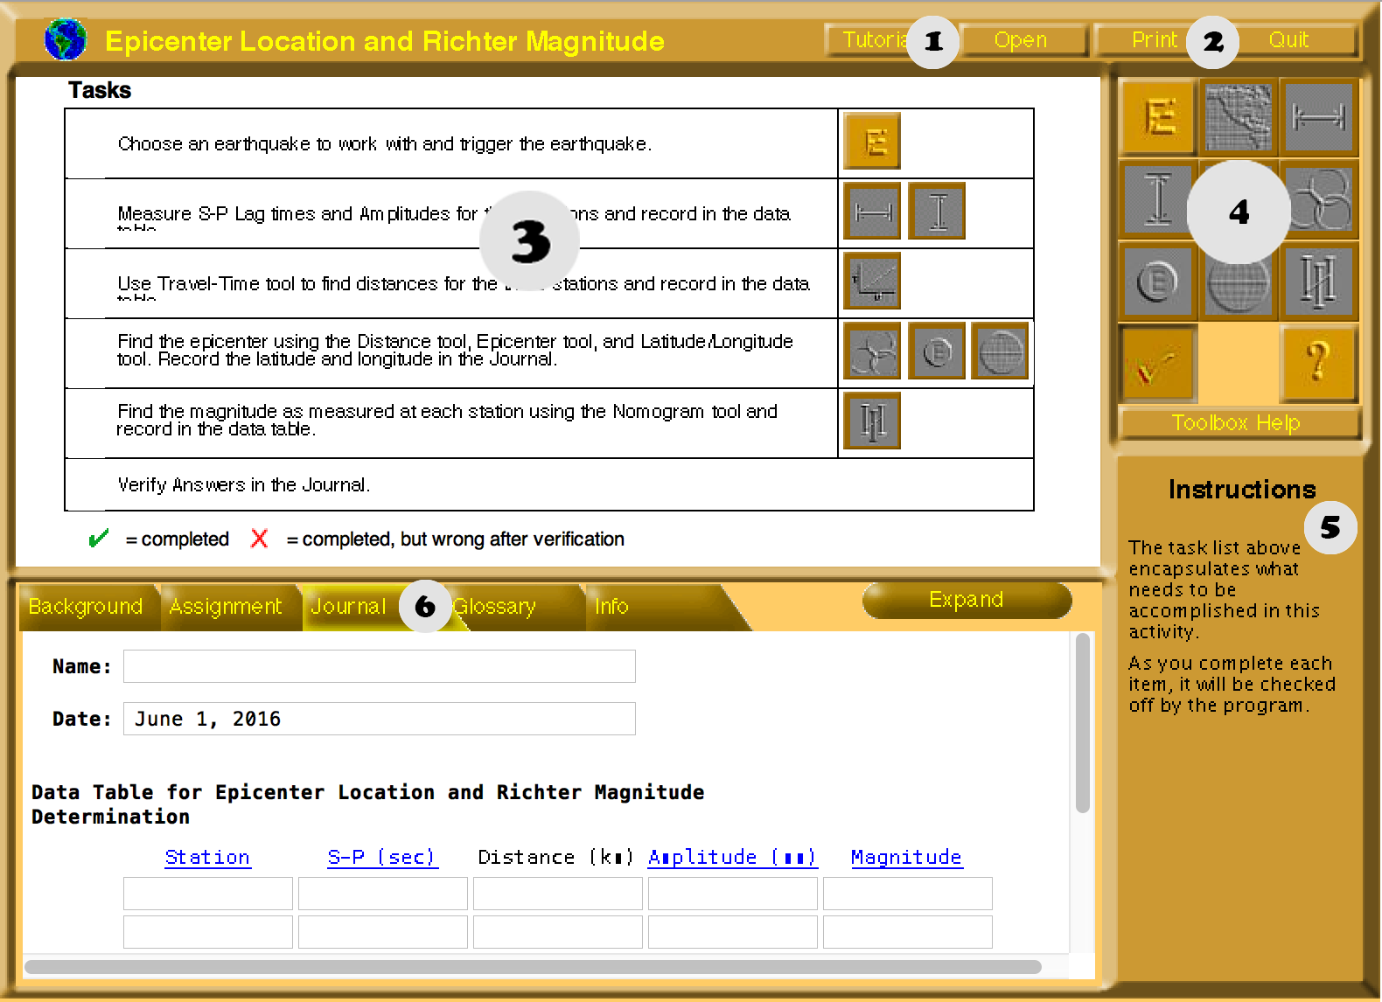

**Key:**

1. Tutorial
2. Print
3. Display
4. Navigation
5. Instructions
6. Journal

**Walkthrough of Application:**

**1.** Click earthquake icon, then click Trigger Earthquake to start earthquake.

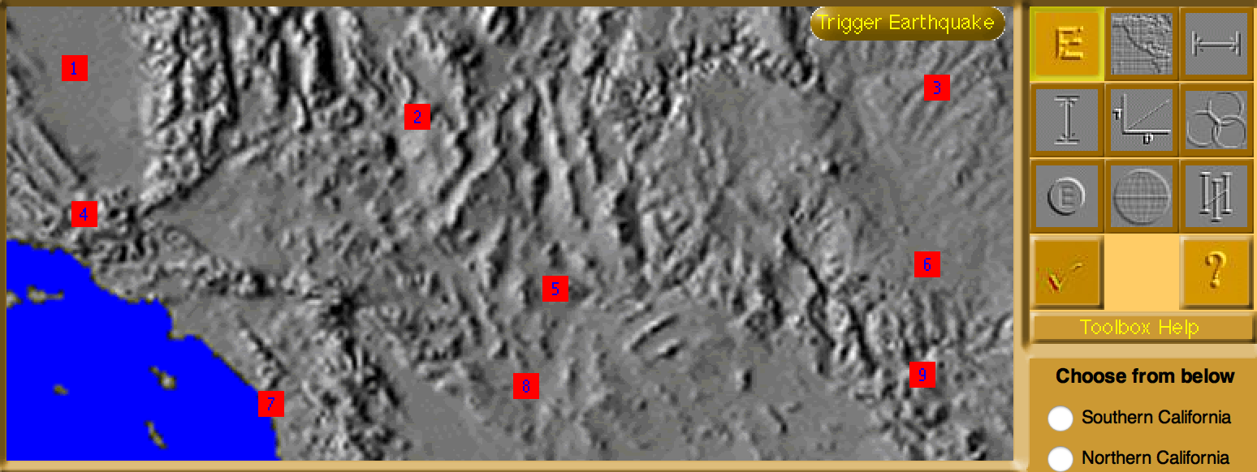

**2.** Click the S&P Tool; This is where you see the smaller and bigger wave from epicenter to the Seismograph station from the previous map.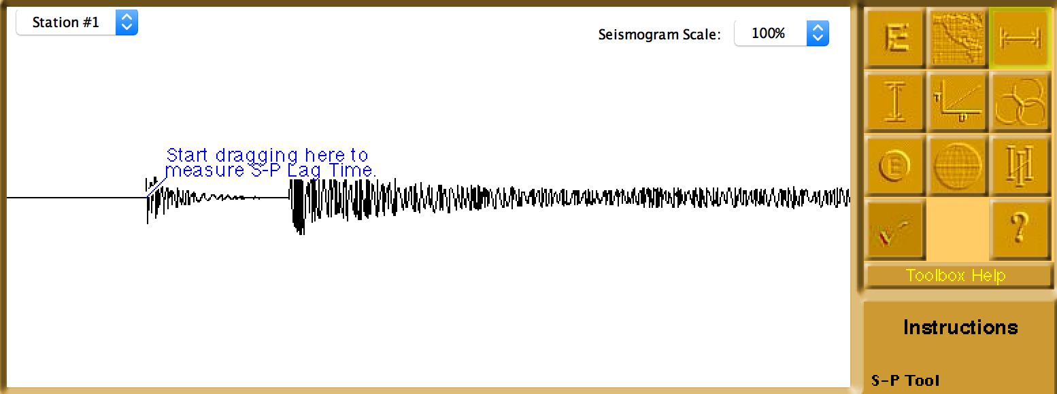

**3.** Pick a station from dropdown box and measure the lag time by click/dragging from the left to right of the smallest wave.

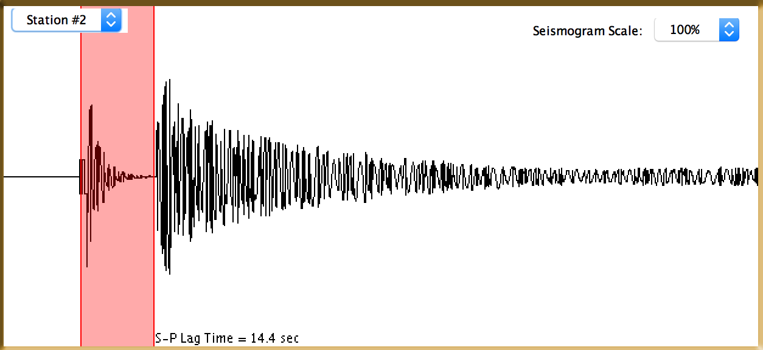

***Note:*** *S-P Lag time in the example. This data will be noted in the journal.*

**4.** Click on the Journal tab and enter the station number and S-P (sec).

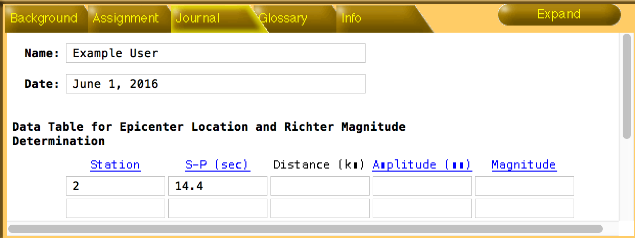

**5.** Next select Amplitude Tool from the navigation bar. This will look similar to previous S-P Lag time. 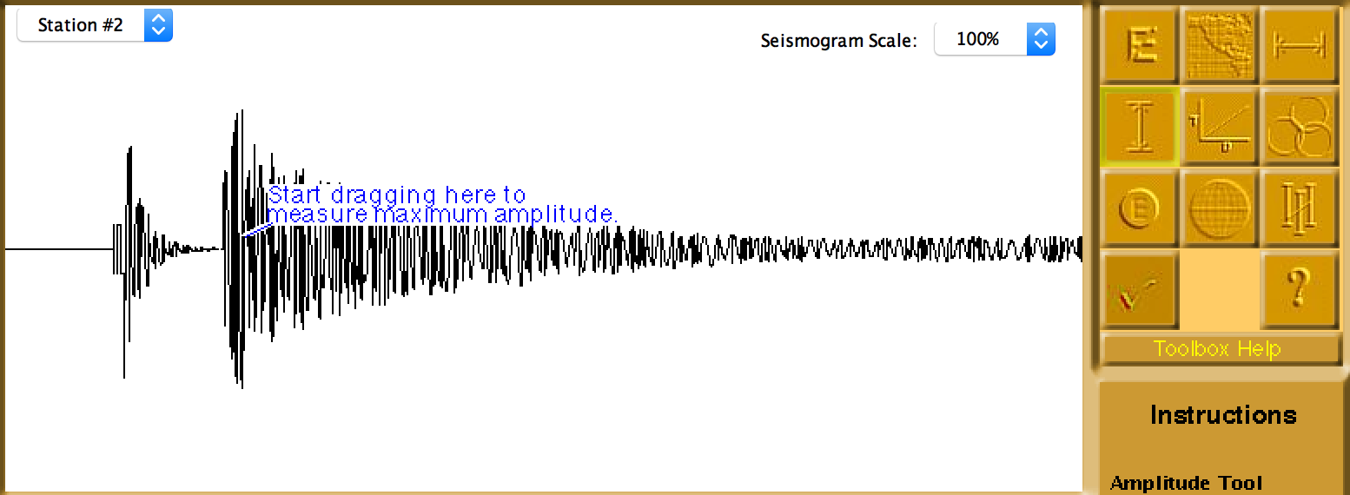

**6.** Click and drag from center of the P-Wave up or down until the measurement covers the highest peak of the wave.

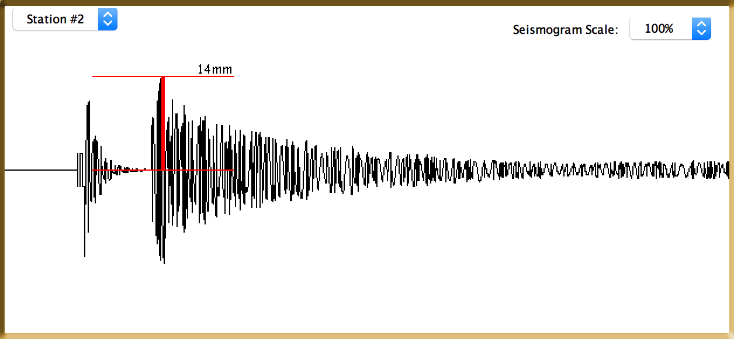

***Note:*** *In the example amplitude for P-wave is 14mm. Also use the Seismogram Scale to adjust wave if too big.*

**7.** Record the station’s measurement to journal. 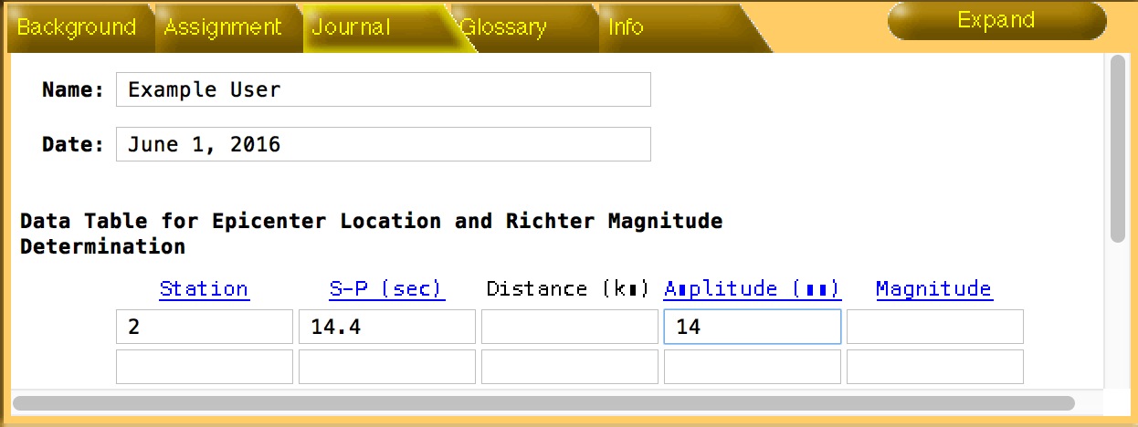

**8.** Click Distance Tool from navigation bar.

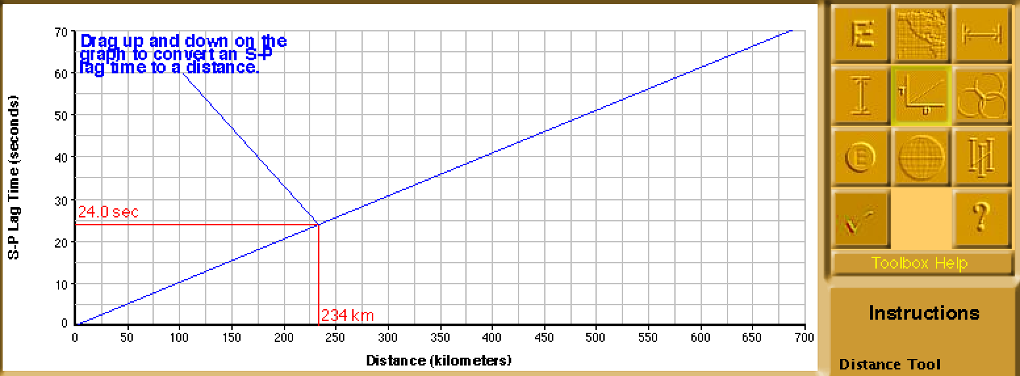

**9.** Next click/drag the red line from distance tool until it matches your station’s S-P Lag time.

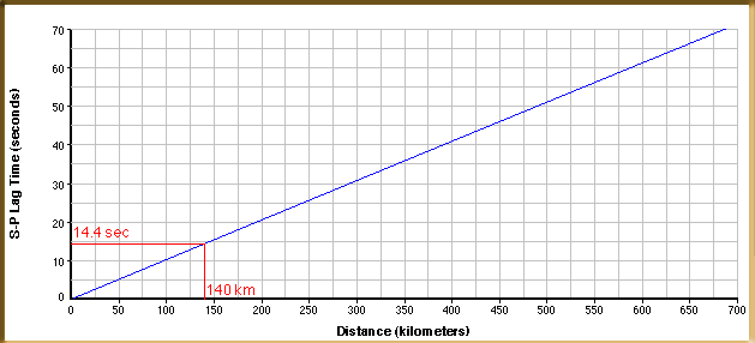

**10.** Document the distance in Journal.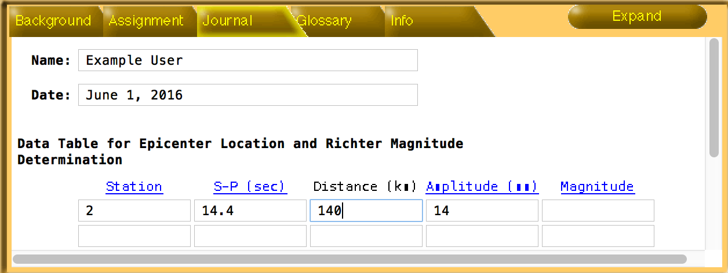

**11.** Repeat process with using other stations and complete Journal entries.

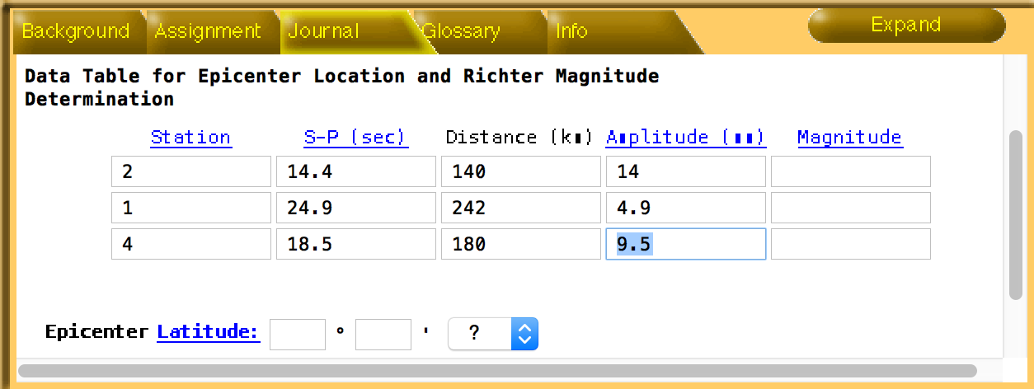

***Note:*** *Pick stations with S-P waves easy to see.*

**12.** Next click Triangulation Tool, if you have recorded three stations. The stations recorded will show up in blue.

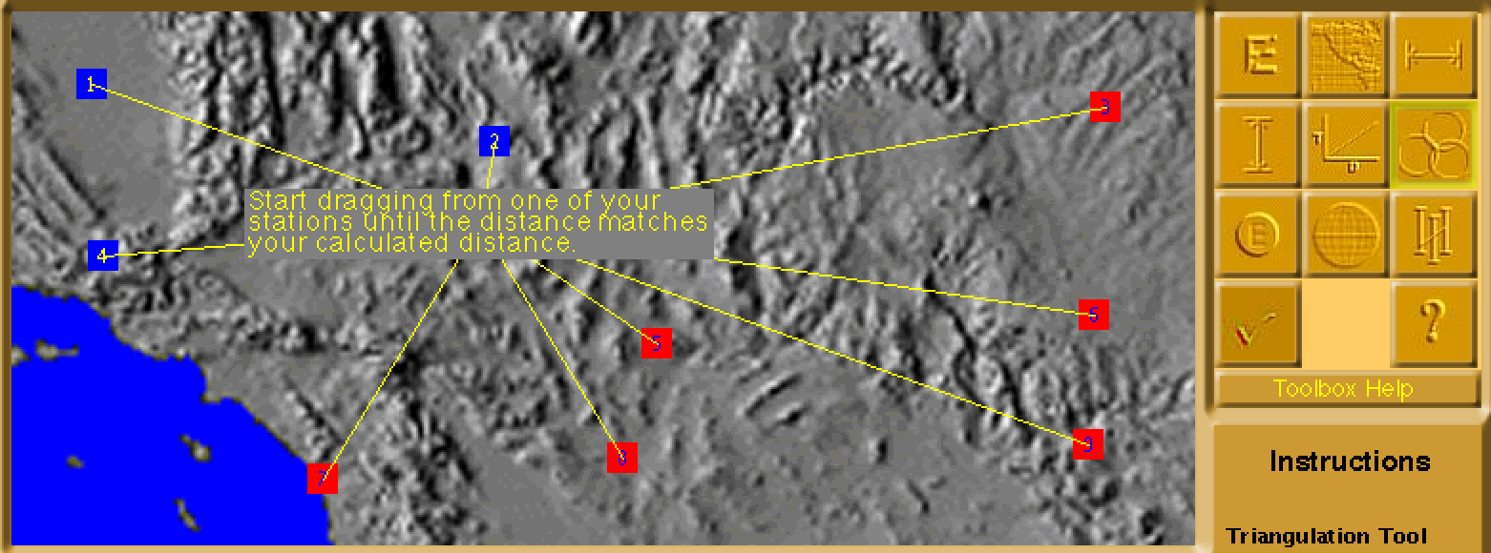

**13.** Click and drag from first station recorded until it displays the distance you calculated.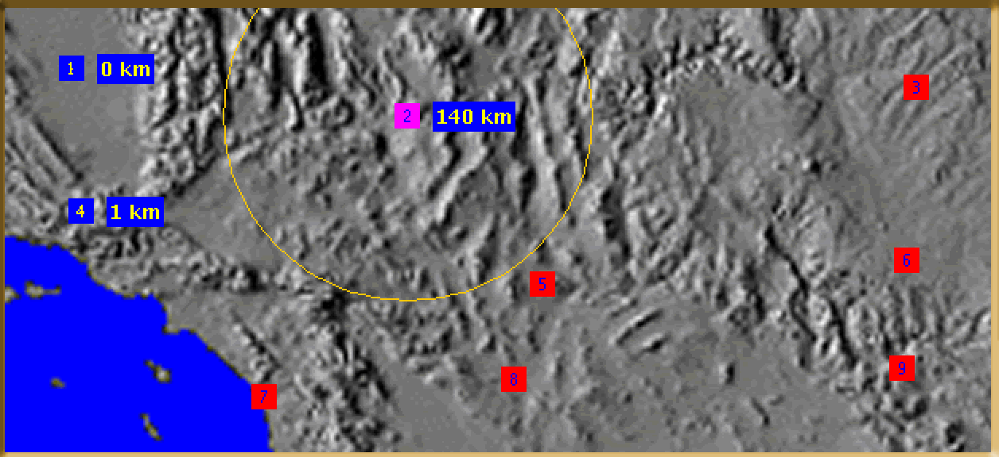

**14.** Repeat with the remaining stations. Where the three circles cross this is your epicenter for the earthquake.

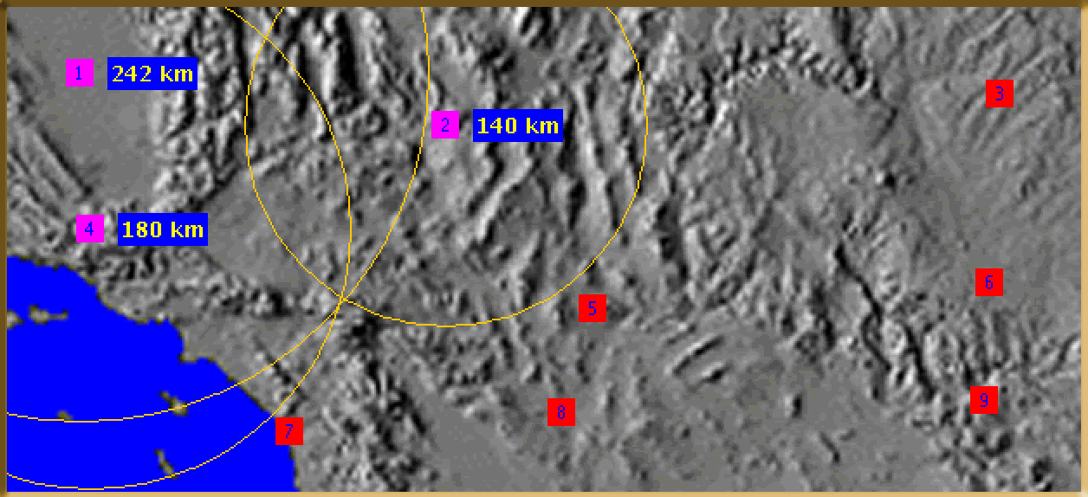

**15.** Click the Epicenter Tool from the navigation bar and an E in a blue circle will appear.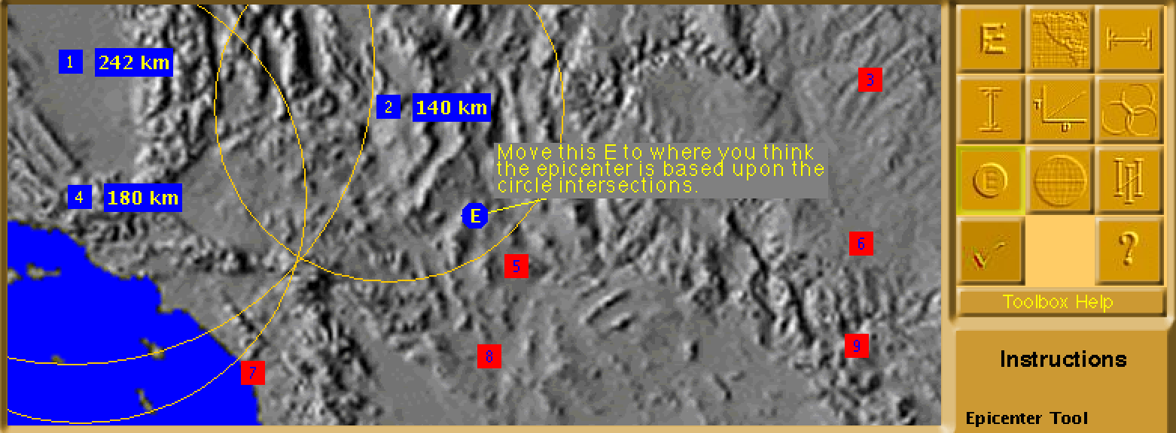

**16.** Drag and drop the E where the three circles cross.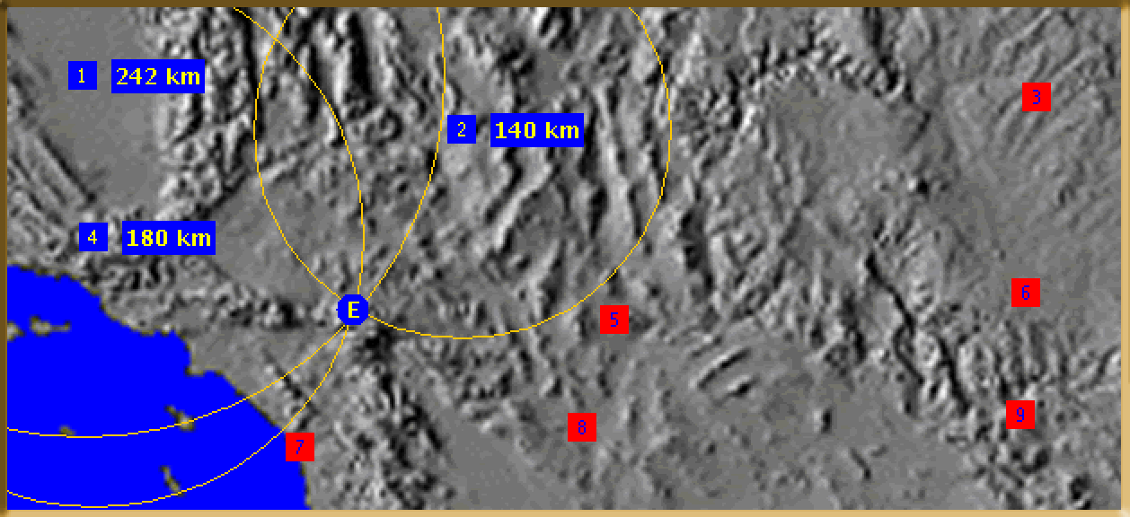

**17.** Next click on Latitude and Longitude Tool, you will see a grid with the E we set as the epicenter.

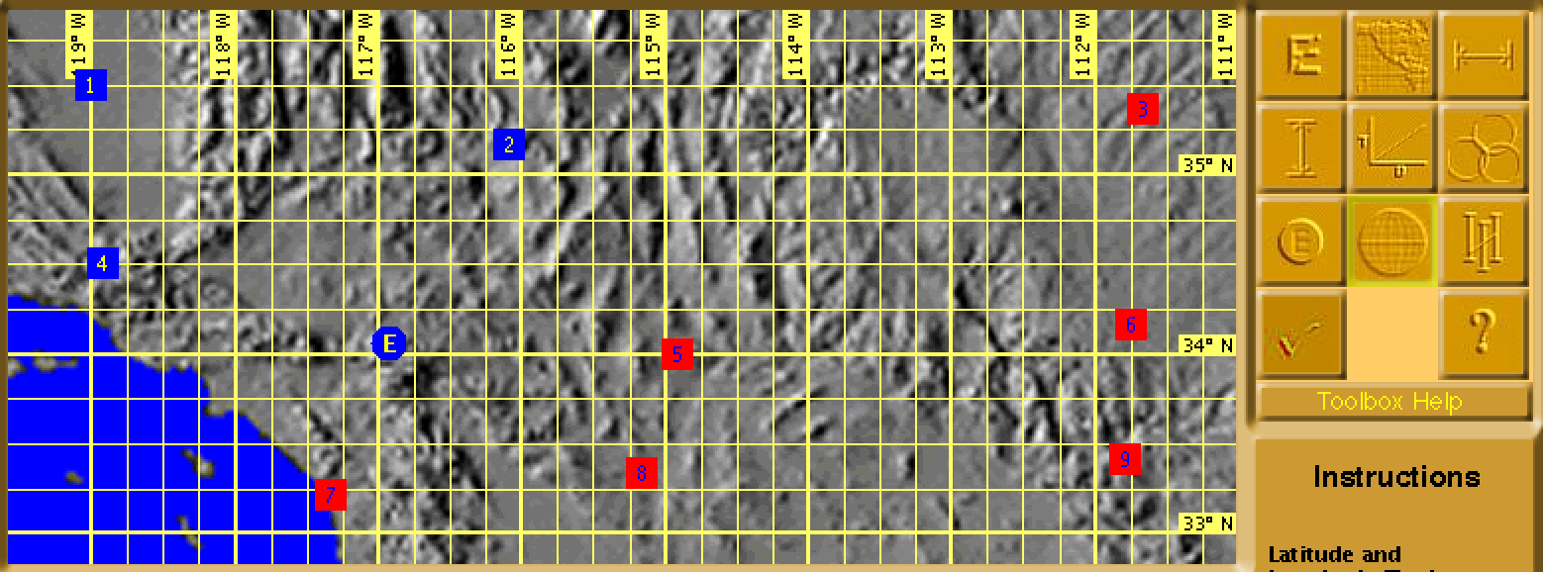

**18.** Using the grid calculate its longitude and latitude. This is then documented in the Journal.

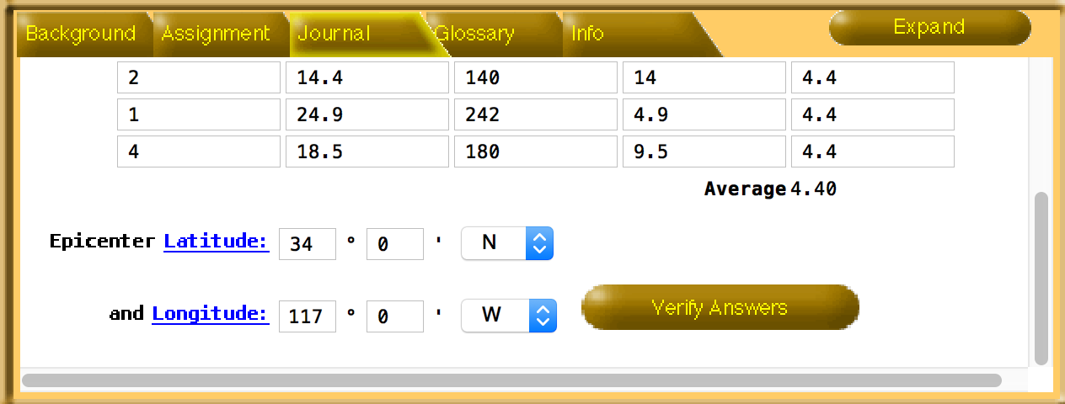

**19.** Next click the Magnitude Tool, use the distance and amplitude of your first recorded station.

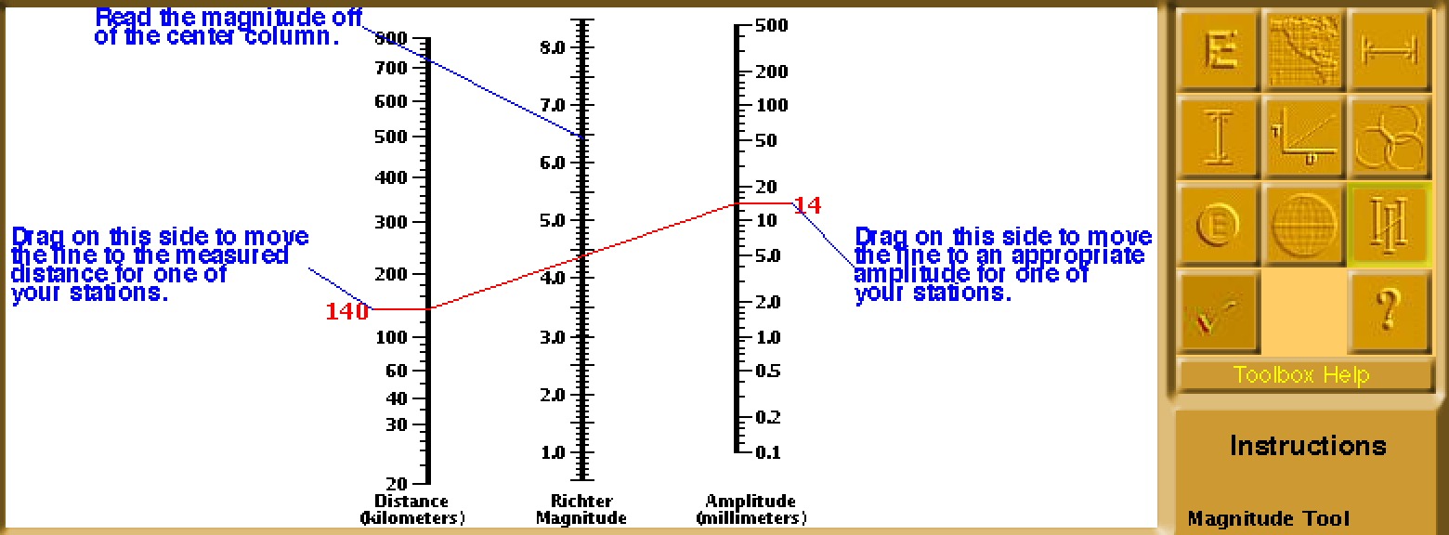

**20.** Record the magnitudes for all three stations. They should be the same.

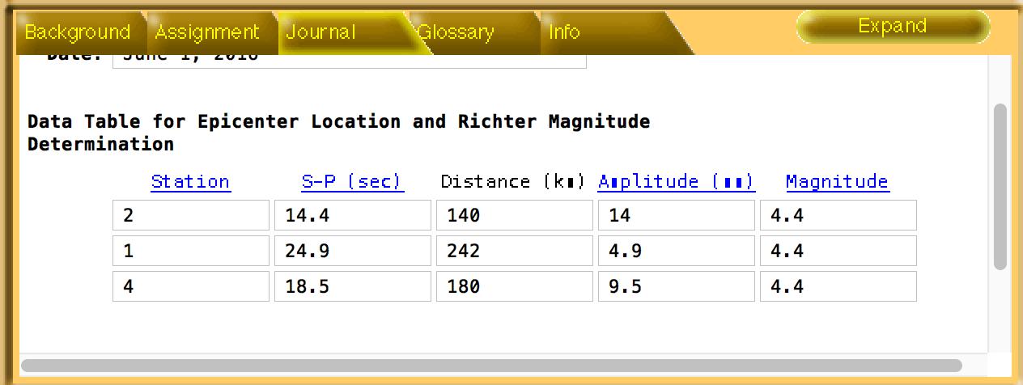

**21.** Next click Instructions to make sure all tasks were correct and completed.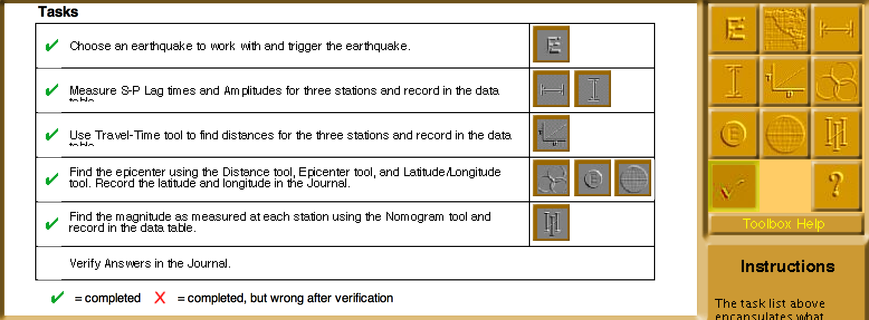

**22.** Lastly click Verify Answers in the Journal tab if correct this is what you will see.

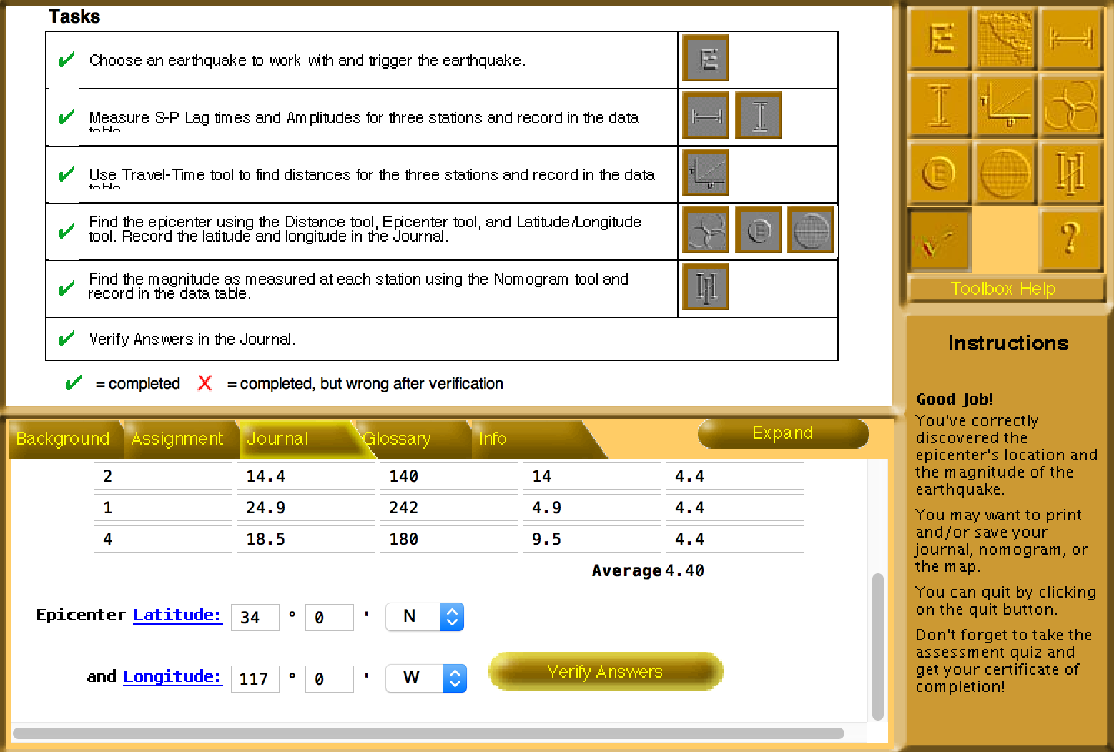

**23.** Click Print button at the top off application, and then select Map and Journal from the pop-up. 